Value Object

The client tier in an EJB system needs a way to transfer bulk data with the server.
How can a client exchange bulk data with the server without making multiple fine-grained network calls?
* * *
In any distributed application there are two ways that a client can interact with a server. The first is to read some data from the server for display purposes; the second is to change some data on the server by creating, updating or removing data. In an EJB context, these types of operations typically involve the exchange of data between the client (servlet, applet, etc), and a Session Bean, Entity Bean, or Message Driven Bean.
When large amounts of data need to be exchanged, this can be achieved by loading many parameters into a method call (when updating data on the server), or by making multiple fine-grained calls to the server to retrieve data (when a client needs to read data from the server). The former option can quickly get out of hand when dealing with large amounts of parameters, and the latter option can be a performance killer.
Imagine the scenario where a client UI needs to display a set of attributes that live on the server, these attributes could live in an entity bean or be accessible through a session bean. One way that the client could get the data it needs is by executing multiple fine-grained calls to the server, as in figure X.1.
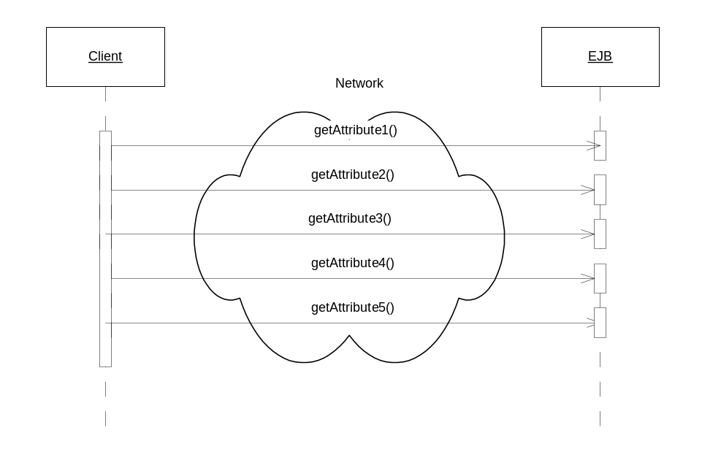
Figure X.1: The wrong way to get data from the server

The problem with this approach is that each call to the server is a network call, requiring serialization and deserialization of return values, blocking on the client while the EJB server intercepts the call to the server and performs transaction and security checks, and of course the retrieval of the attribute in question. Furthermore, each method call might actually execute in its own separate transaction if the client is not using Java Transaction API client demarcated transactions.
Executing multiple network calls in this fashion will contribute to significant degradation in performance. A better alternative is required, one that would allow the client to get all the data it requires in one bulk call.
Therefore,
Create plain java classes called Value Objects, which contain and encapsulate bulk data in one network transportable bundle.
A value object is a plain serializable Java class that represents a snapshot of some server side data, as in the following code example:

import java.io.Serializable;

public class SomeValueObject implements Serializable {

private long attribute1;
private String attribute2;
private String attribute3;

…

public long getAttribute1();
public String getAttribute2();
public String getAttribute3();
…

}//SomeValueObject

Value objects can be used both for the reading operations and the update operations in a distributed system. When a client needs to update some data in the server, it can create a Value Object that wraps all the information the server needs to perform the updates, and send it to the server (usually to a Session Façade) for processing. Of course, it could also send data to the server using zillions of fine-grained parameters, but this is a very brittle approach. Whenever one parameter needs to be added or removed, the method signature needs to change. By wrapping with a value object, changes are isolated to the value object itself.
Where Value Objects are clearly needed is for reading operations. When a client needs to read some server side data (usually for the purpose of populating a client-side UI), the client can get all the data it needs in one bulk network call by wrapping the data in Value Object form.
From the previous example, the server side EJB would create a value object (as in figure X.2) and populate it with the attributes that the client required. This data would then be returned to the client in one bulk return value – the value object.

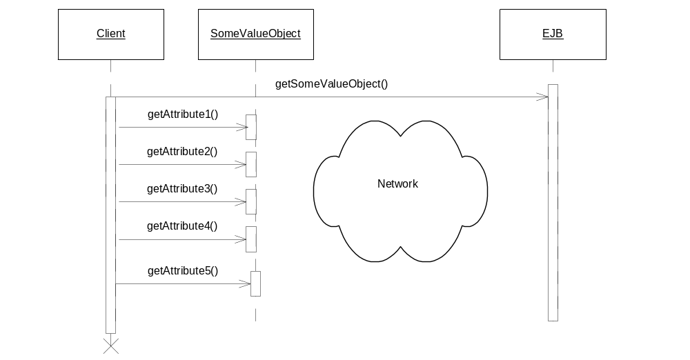
Figure X.1: The right way to read data from the server

Value objects are basically ‘envelopes’, used to transport any kind of data between the tiers in a J2EE system.
A common problem developers face when using value objects is choosing at what granularity to design them. That is, how do you choose how much data to wrap with a value object? At what point do you decide a value object is necessary? As the primary method of exchange between client and server, value objects form part of the interface that separates client developers and server developers. At the beginning of a project, client and server developers need to agree on the value object design at about the same time they need to decide upon what EJB interfaces. Despite this need, designing value objects at this stage can be difficult since developers often don’t completely understand exactly what units of data should be transferred between client and server, at the beginning of a project.
A easy place to start in designing value objects is as copies of server side entity beans (or domain objects), as described in the Domain Value Object pattern. Designing Domain Value Objects is easy, as project teams usually have a good idea the domain model a project will utilize early on, since these requirements are established initial design phases. Thus, making Domain Value Objects the unit of exchange between client and server can help get a team up and running quicker.
Ultimately, data exchanged between the client and server should be designed to fit the client’s needs. Thus, as the project progresses and the needs of the clients become finalized, Domain Value Objects often become cumbersome as units of exchange, too coarse grained to be useful to the fine-grained needs of the client. A client may need access to data that simply isn’t encapsulated in any Domain Value Objects. At this point, developers can design Custom Value Objects, that is, value objects that wrap arbitrary sets of data, completely driven on the particular needs of the client.
The differences between these two design paradigms can have significant impact on the design of the application as a whole. Although they are mutually exclusive, they can and usually do co-exist in any J2EE application.
When deciding where to put the logic to create and consume value objects, the Value Object Factory pattern illustrates a proven and maintainable solution.

Domain Value Object

A client wants to access and manipulate data from the server side domain object model.
How can a client access and manipulate the server side domain (entity bean) object model without the performance overhead of remote calls?
A domain model, or domain object model refers to the layer of objects in your system that map to real world concepts, such as a Person, a Bank Account, or a Car. In an EJB setting, the most common example of a domain model is your application specific layer of entity beans. A Domain Object in this sense is a particular entity bean, such as a Car entity bean. Other technologies for creating domain models can also be used in an EJB setting, such as Java Data Objects, Data Access Objects, or the proprietary domain object layer provided by an object-relational mapping tool.
In a distributed scenario, domain object models live completely on the server. However, depending on the implementation technology chosen (entity beans, JDO, etc), a domain object model can manifest itself into two types: one that can be accessed by clients remotely across a network (entity beans), and one that cannot be accessed by clients remotely (JDO, proprietary frameworks, etc). For the latter, only other business components on living on the server can access the domain model.
Entity beans are a remotely accessible. A client can access an EJBObject stub that maintains a direct connection to a particular entity bean living on the EJB server across a network. However, as explained in the Session Façade pattern, accessing entity beans remotely is a very poor practice. The most powerful way to optimize on entity bean access is not to access entity beans from the client at all. Instead, a client would execute a method on a Session Façade, which would directly interact with entity beans through their local interfaces, allowing complex operations to be completed in one network call. Using the Session Façade pattern, entity beans are thus no longer accessible by a client across a network.
This optimizes on the performance problems associated with using entity beans directly from clients, but puts the client in a difficult situation: If the client cannot access entity beans (or any type of domain object), how can it work with the same data object abstractions (the same domain model) on the client side as are being used on the server side? How is a client to read and display the attributes of a particular domain object that lives on the server side, and work with this data using the same object oriented semantics on the client side?
For example, consider a Car dealership application, in which the business requirements of the system define the notion of a Car and a Manufacturer, implemented as entity beans on the server side. For the client-side portion of this application, the most intuitive thing to do would be to also display and update similar Car and Manufacturer abstractions on the client side. A client could read data from the Car and Manufacturer, update values on the Car and Manufacturer and naturally traverse relationships to other related entity beans if it needed data from them.
Performance concerns require that the client not have direct access to the entity bean domain object model, and other types of object domain models cannot even be accessed remotely. However, to be able to work with an applications domain model on the client side is desirable. Thus, a mechanism is needed to allow clients to traverse and manipulate the same data object abstractions as exist on the server.
Therefore,
Design Value Object copies of the server side domain objects (entity beans). Clients may operate on local value object copies of domain object data, performing bulk reads and updates.
Domain Value Objects are a special application of the Value Object pattern. Whereas the Value Object pattern simple says to use Value Objects to exchange data between client and server, the Domain Value Object pattern says that Value Objects can be used to provide clients with optimized local access to value object copies of server side domain objects. Thus, Domain Value Objects have one-to-one correspondence with domain objects on the server side. If you have an Account entity bean, then you will have an Account value object, as in figure X.1.
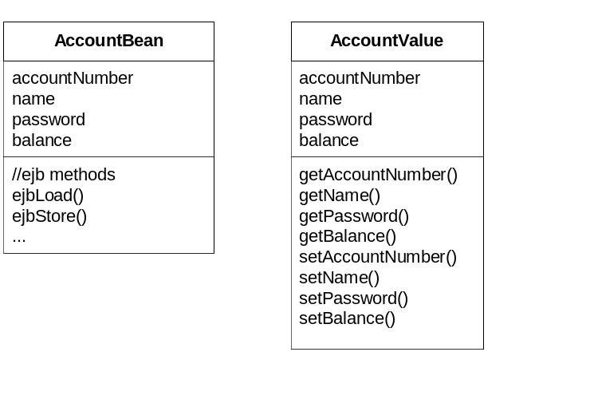
Figure X.1: Account EJB and Account Value Object

Using Domain Value Objects provides a simple way for clients to interact with the entity bean object model in a distributed application:
Displaying entity bean data. When a client wants to display the data from an Account entity bean, it could call a getValueObject method on the Account, which would retrieve an AccountValueObject, containing a copy of all the attributes of the Account Entity Bean. The client could then perform multiple get calls on this local value object, without the burden of network calls.
Modifying entity bean data. If a client wants to modify the contents of the Account entity bean, it would perform its update by calling set methods on its local copy of the AccountValueObject, then pass this updated value object to the server for merging with the Account Entity Bean.
Displaying data from that spans related entity beans. Entity beans can contain references to other entity beans in a one to one, one to many, or many to many fashion. Often a client will be interested in getting data from multiple related entity beans, but manually traversing to get separate value object copies would involve significant network call overhead. A better solution would be to assemble a value object copy of these related entity beans on the server side, and pass it to the client in one network call. This can be achieved using special value objects called Aggregate Value Objects (value objects that contain references to other value objects). Aggregate Value Objects can be created that contain value object copies of hierarchies of related entity beans. The client would navigate this local hierarchy of value objects just as if it would navigate the remote entity beans themselves.
Creating entity beans. To create a new Account, a client could locally create and populate an AccountValueObject, and pass this object to the Session Façade, which would use it in the ejbCreate method on the AccountHome. The less maintainable alternative would be to pass all the attributes of the Account as method parameters to the session façade and then to ejbCreate(). For example, which looks more maintainable: ejbCreate(attrib1, attrib2, attrib3, attrib4, attrib5, …), or ejbCreate( aValueObject)?

Much debate has arisen as to whether Value Objects should be mutable or immutable. That is, should a client be allowed to modify a value object (by calling set methods on it), or should value objects be read-only, without set methods. When using Domain Value Objects, it makes sense to make them mutable. The client knows it is interacting with a client side copy of an entity bean, it can read and update the value object as though it were doing so on the entity bean itself. Since the client knows the value object came from the server, it is reasonable to give it the responsibility of knowing to send the value object back to the server once modifications have been made. Where immutable value objects make sense is when value objects don’t represent server side entity beans, such as in the Custom Value Object pattern. Here, value objects simply represent arbitrary collections of read-only data, and updates should not be performed through the value objects.

Designing Value Objects as copies of server side entity beans has the following benefits:
Domain model data structures replicated to client in one network call. Copies of entity beans and even multiple entity beans can be assembled on the server and passed to the client in one network call. The client can then traverse the local value objects, reading and updating without incurring network call overhead. A client can then update the server by passing the value object back.
Easy to quickly build a functional site. Early in the development process, the specific data access needs of the client is unclear and always changing. Whereas the needs of the client UI’s are unclear, the applications entity beans object model is has usually already been built. A functional application can quickly be built using the entity bean value objects as the medium of exchange between client and server.
Client-side attribute validation. Syntactic validation of entity bean attributes can be performed on the client side by embedding this validation logic in value object set methods. This allows errors with entity bean editing and creation to be caught on the client side instead of using up a network call only to have exceptions be thrown from the server.

As well as the following tradeoffs:
Couples client to server side domain object model. With the domain value object pattern, a client is working with a direct copy of a server side domain object (entity bean). Thus, Session Façade or not, the client is effectively coupled to object model that lives on the server. If an entity bean is changed, its corresponding value object must be changed, thus any clients using that value object must be recompiled.
Does not always map well to needs of clients. The entity bean object model used on the server side often does not map well to the clients needs. Different UI’s may require different sets of data that simply don’t map to ‘bundles of data’ that entity bean value objects provide. A client may want one or two attributes of an entity bean that has 20 attributes. To use a Domain Value Object to transfer 20 attributes to the client when only two are needed is a waste of network resources.
Results in a parallel hierarchy. Domain Value Objects duplicate objects in the domain model, resulting in duplicate attributes and methods.
Combersome for updating domain objects. Merging changes from an aggregate value object (a domain object that contains other domain objects), is difficult and cumbersome. What if only one domain value object deep in the tree was changed? Ugly code needs to be written to detect this.

The reader may have noted that the above examples have implied that domain value objects could be created and consumed by the entity beans themselves. Back in the EJB 1.X days (before entity beans had local interfaces), it was common to see entity beans expose a getValueObject and a setValueObject method, instead of fine-grained getAttribute/setAttribute methods. Every entity bean in an application housed logic that created a value object copy of itself (getValueObject) and logic that updated itself based on changed values in a value object (setValueObject). The reason was that all calls to an entity bean were potentially remote calls, even if they came from session beans or other entity beans co-located in the same server. The Domain Value Object pattern arose out of this need to optimize on calls to entity beans, be they from non-ejb clients or from other session and entity beans. With the introduction of EJB 2.0 local interfaces, session beans and other entity beans no longer need to use value objects to optimize on entity bean data access. Instead, they can simply use fine-grained getAttribute/setAttribute methods on the entity bean, now Domain Value Objects be used properly: to exchange domain object copies between client and server.
Since domain value objects should not be created and consumed on the domain objects themselves, this begs the question: Where should value objects be created and consumed? The Value Object Factory pattern provides a best practice for this type of code. Another related pattern is the Custom Value Object pattern, which takes the opposite perspective to the entity bean value object pattern: Value Objects should be immutable, and map to the specific needs of the client, not the domain model.

Custom Value Objects

A client finds that the domain object model and associated domain value objects don’t map well to its needs.
How can value objects be designed when domain value objects don’t fit?
The Value Object pattern introduced the notion of using a value object to pass bulk data between client and server. The Domain Value Object pattern described a common method of designing value objects – by mapping directly to the object model used on the server side. Although this method of designing value objects works well early on in a project, EJB clients often have much more fine-grained data access needs.
For example, consider a Car entity bean. A Car could potentially be described by hundreds of attributes (colour, weight, model, length, width, height, year, etc). In most typical scenario’s, a client is only interested in a small subset of those attributes. For example, consider a web page that lists a cars model, year and type. To populate this page, it would be extremely wasteful to transfer a CarValueObject (with all its attributes) to the client, when it only wants to list 3 simple attributes from the car.
A client may have even more complicated needs. Imagine a client that required just one or two attributes from 5 different related entity beans. In order to optimize on network calls, a value object representation could be constructed on the server side that wraps all the required data into one network transportable bundle. One solution would be to create a Domain Value Object that contains links to other domain value objects. Thus the hierarchy of entity beans on the server side would be copied into a symmetric hierarchy of domain value objects. This approach is terrible for performance and cumbersome in practice. If a client only needs one or two attributes from each server side entity bean, transferring the complete domain object model as value objects to the client would waste time and network bandwidth.
Another problem is that often a client may be require data that comes from a variety of data sources other than the domain objects on the server. Datasources such as straight JDBC calls, Java Connector Architecture (JCA) adapters, also need to be wrapped in value objects and returned to the client.
Therefore,
Design custom value objects that wrap arbitrary sets of data as needed by the client, completely decoupled from the layout of the domain model on the server.
Custom Value Objects are just like normal value objects, except they are typically immutable and don’t map to any specific data structures on the server (in contrast to mutable domain value objects). Custom Value Objects advocate a use case driven approach, in which value objects are designed around the needs of the client.
From the Car example, imagine a client only wanted to display the attributes of a car related to its engine. For this case, a value object that wraps those particular attributes should be created and passed to the client. This custom value object would contain a subset of the Car’s attributes, as in figure X.1.
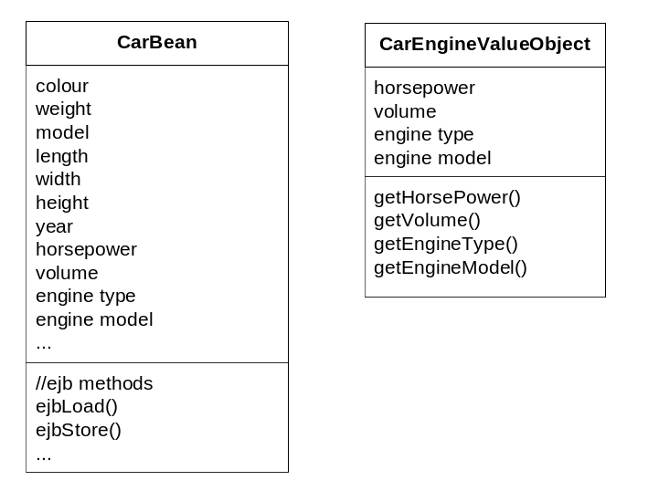
Figure X.1: A Custom Value Object wrapping a subset of data

In general, if an EJB client requires attributes X,Y and Z, then a value object that wraps X,Y and Z, and only those attributes would be created. With this approach, a value object acts as contract that provides the client with the data it needs, while encapsulating the data that the server has. Custom value object design works perfectly with the Session Façade pattern, in which the details of the entity bean object model are hidden behind a set of session beans. The correct way to think of value objects in this respect is merely as data and not as representing any server side business abstraction such as an entity bean. If all of the data happens to come from one entity bean, fine; but if not, that's the server's problem of how to populate the value object and doesn't concern the client.
Custom Value Objects are typically used for UI-specific read-only operations, and are made immutable. That is, Custom Value Objects cannot be changed; they are only for display purposes. Since a Custom value object is merely a grouping of data, and not really related to any server side business object, it doesn’t make sense to update it. Typically, updates are done via entity bean value objects (since they represent a real business object and can encapsulate validation logic) or through use-case specific methods on Session Facades.
Custom Value Objects are almost always created via a Value Object Factory (see the Value Object Factory pattern), and are tied to the specific needs of the client.

